KOTKAN NUORET JOUSET MUSIC CAMP 2026
Eurovision
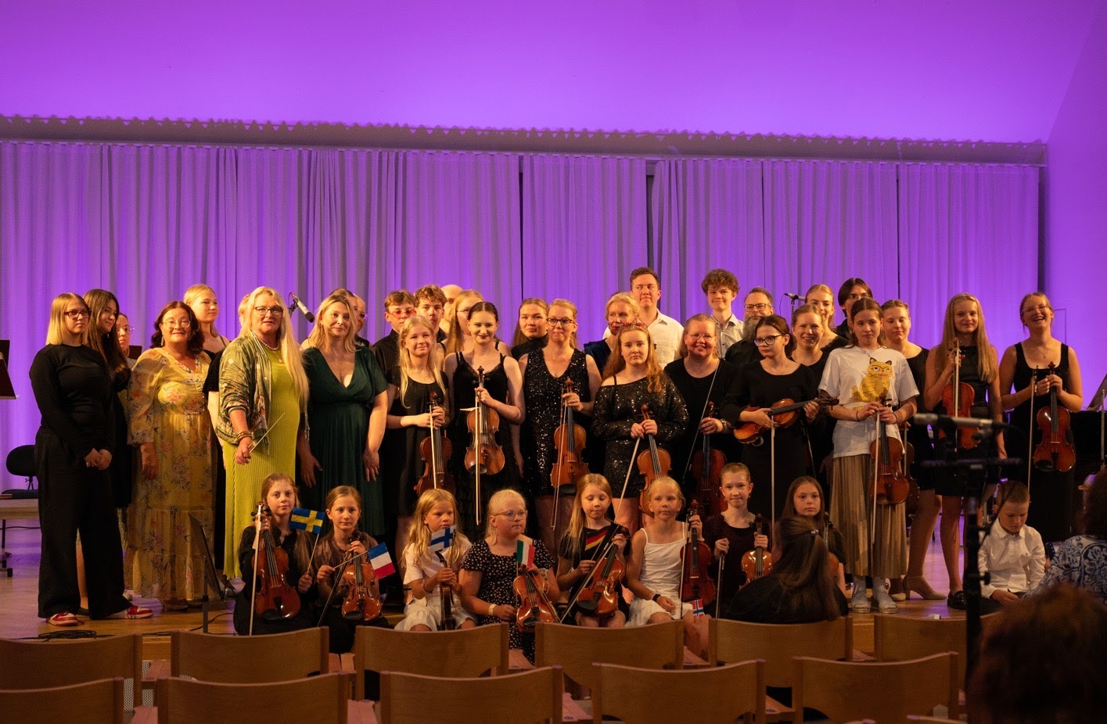

Annual Kotkan Nuoret Jouset Music Camp was held on 26-30.7.2026 in Pyhtää Munapirtti in a lovely place called Seahotel Mäntyniemi, which is surrounded by the beautiful sea and nature. This year's theme for the camp was the Eurovision Song Contest. 31 students and 17 adults participated in the camp and travelled through Europe led by music.

The first camp day started with a teachers meeting. Students arrived after that. The welcome event was held in the cafeteria after which a delicious lunch was enjoyed and students proceeded to their private lessons. In the afternoon there was a group practice (Tutti). The first evening was spent getting to know each other and crafting Eurovision-passports for the upcoming days. Also a funny Eurovision quiz was held for the students.
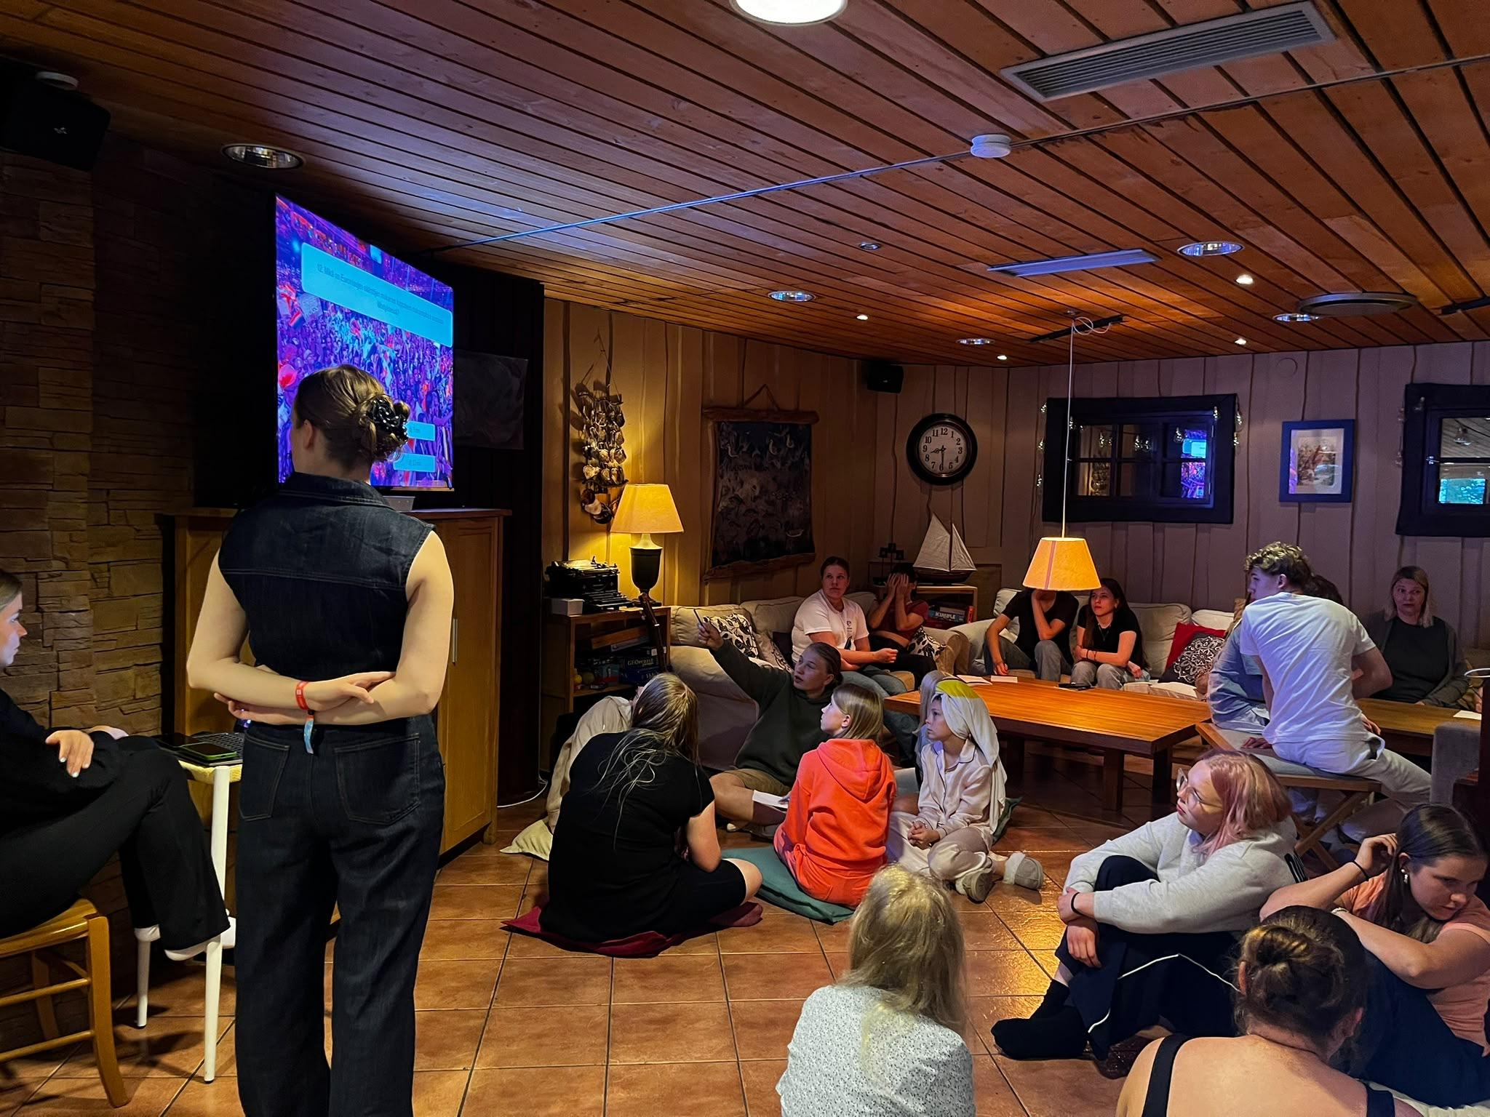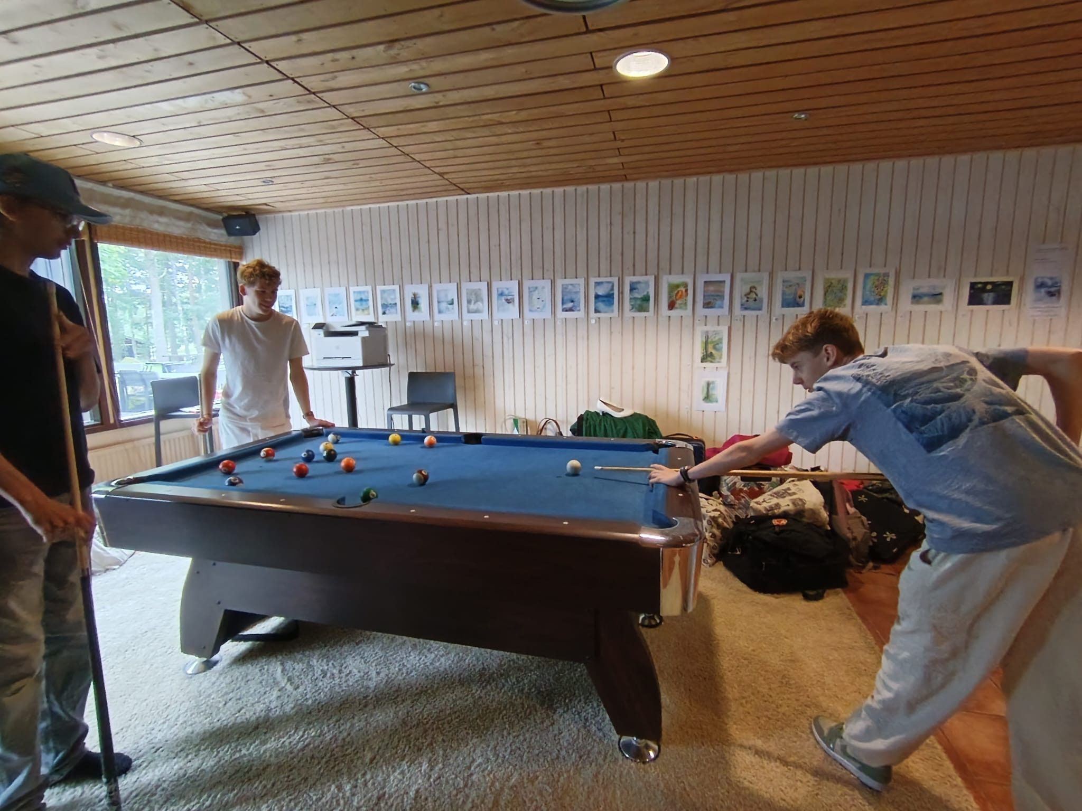

The second day was far more eventful. Morning started with a Warm Up, a lovely breakfast and string sectionals where each string part met to work on specific passages, intonations, rhythms and other things on their own. Private lessons, band meetings and improvisation classes started after sectional practice. In the midday campers enjoyed lunch, and the food had time to settle during the choir rehearsals. After choir the private lessons continued. Right at the end of the schedule was the group practice all together with the whole camp. On Monday the evening included grilling, swimming and fun karaoke time. The karaoke session once again featured a series of captivating performances from both students and teachers. We had so much fun!
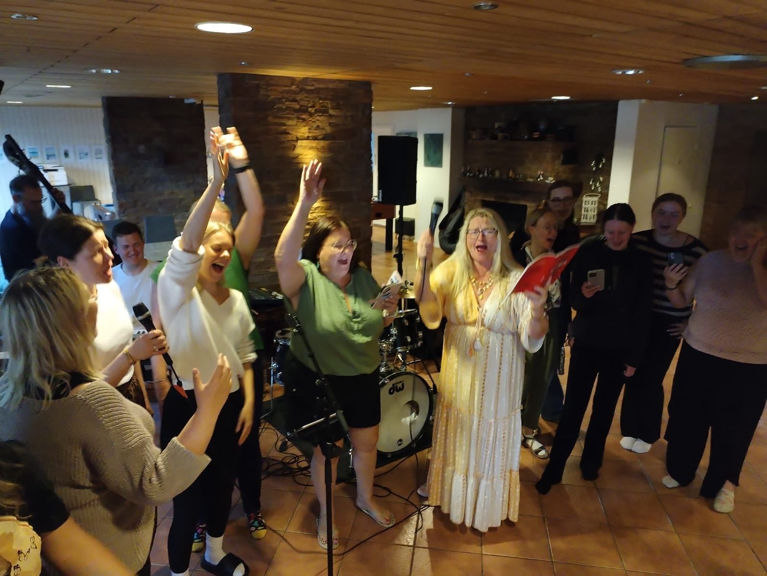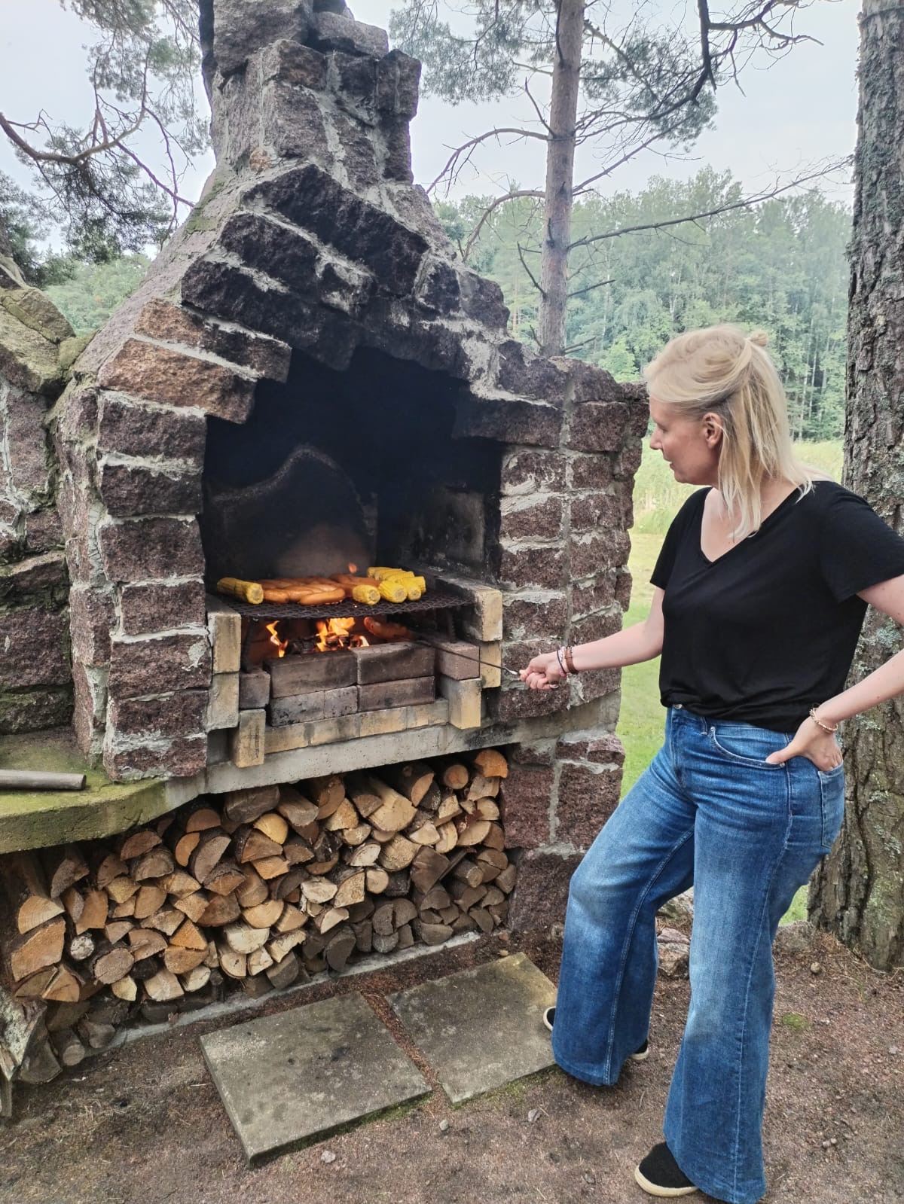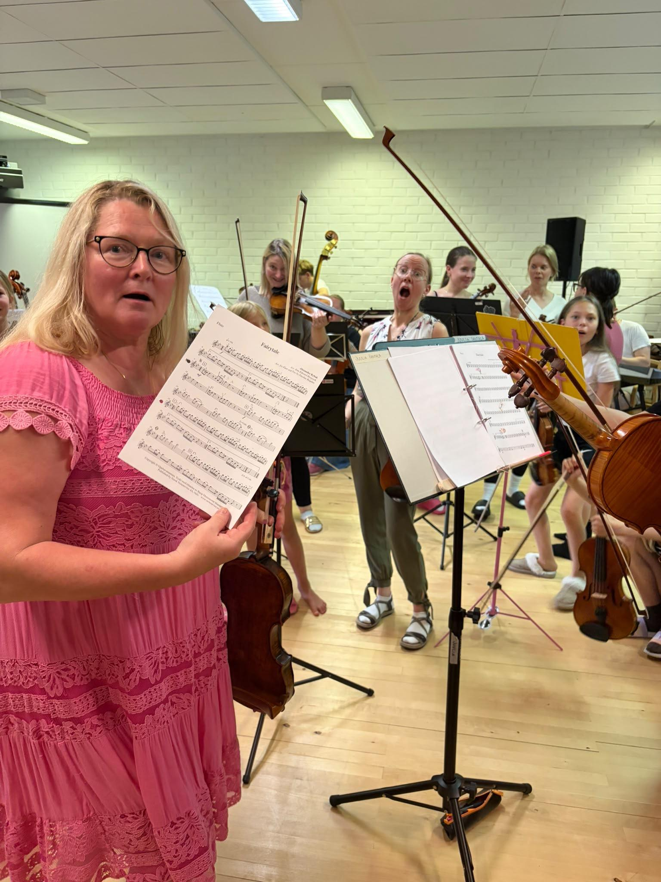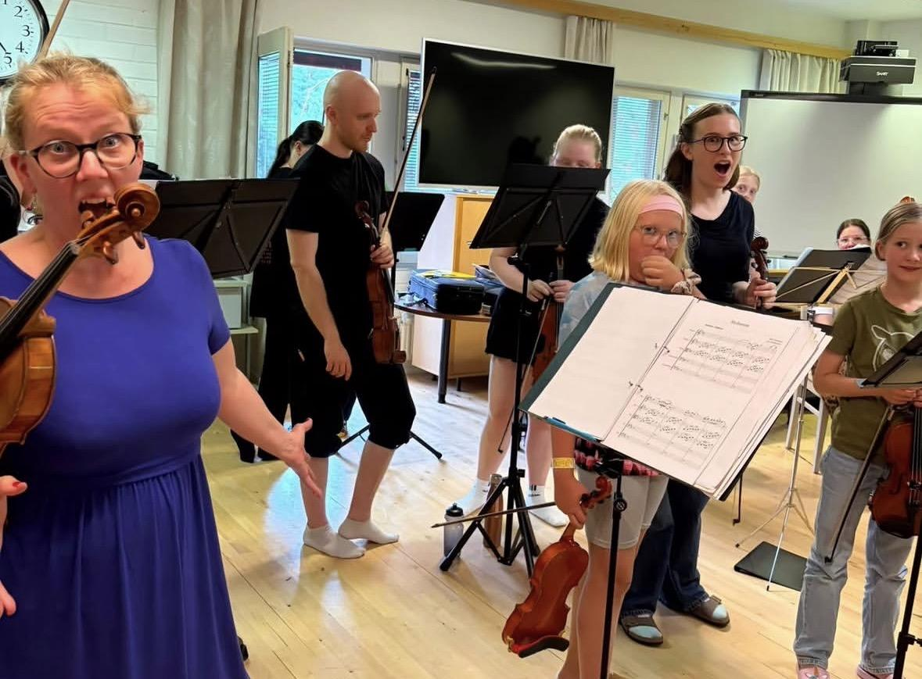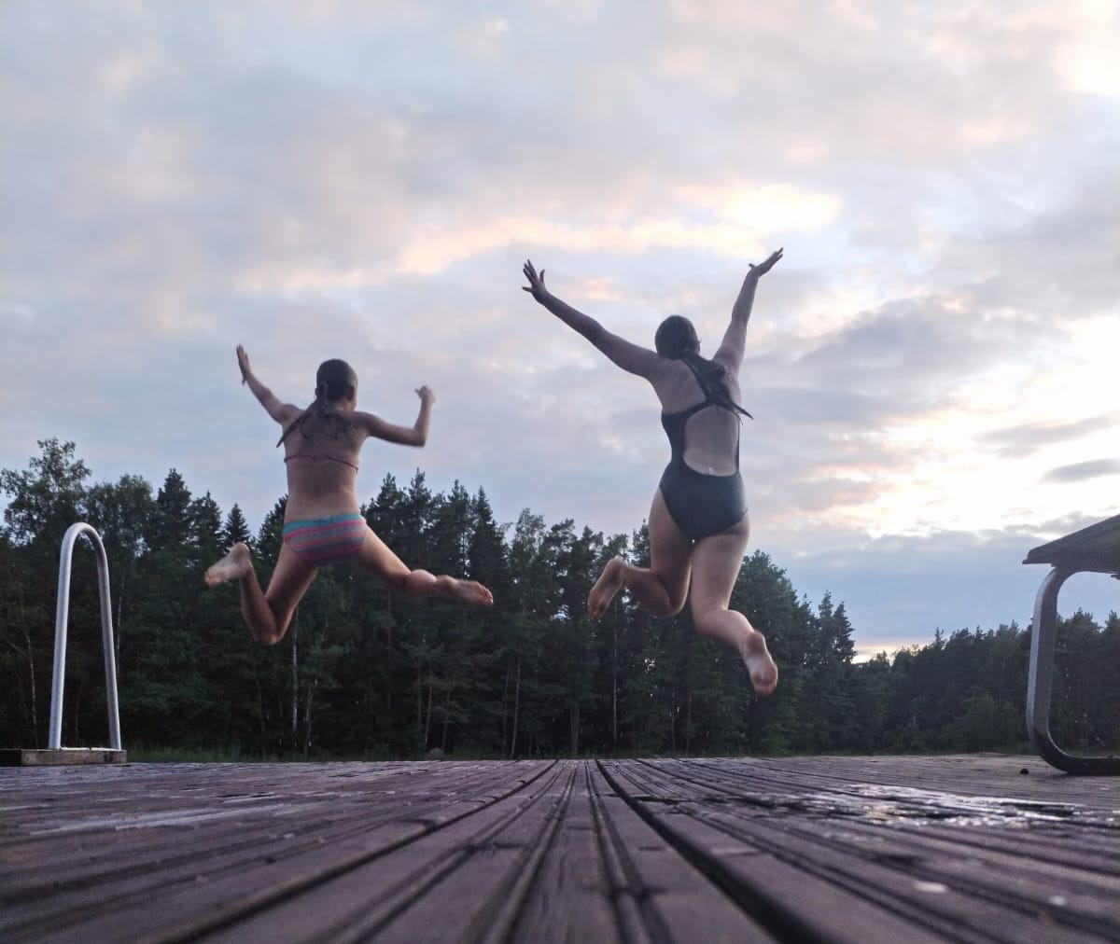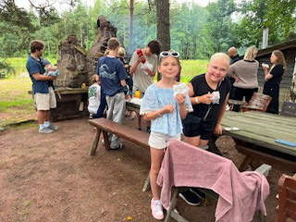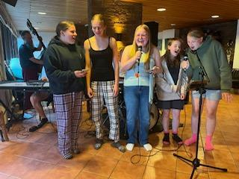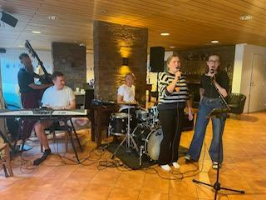

Tuesday was the third camp day and it followed Monday's schedule. Morning started with funny passport and security checkups and an open stage concert (Estradi vapaa) was held in the evening. Many students performed their own music repertoire in the open stage. The performances were heartwarming. A sauna also warmed the campers at the end of the evening.
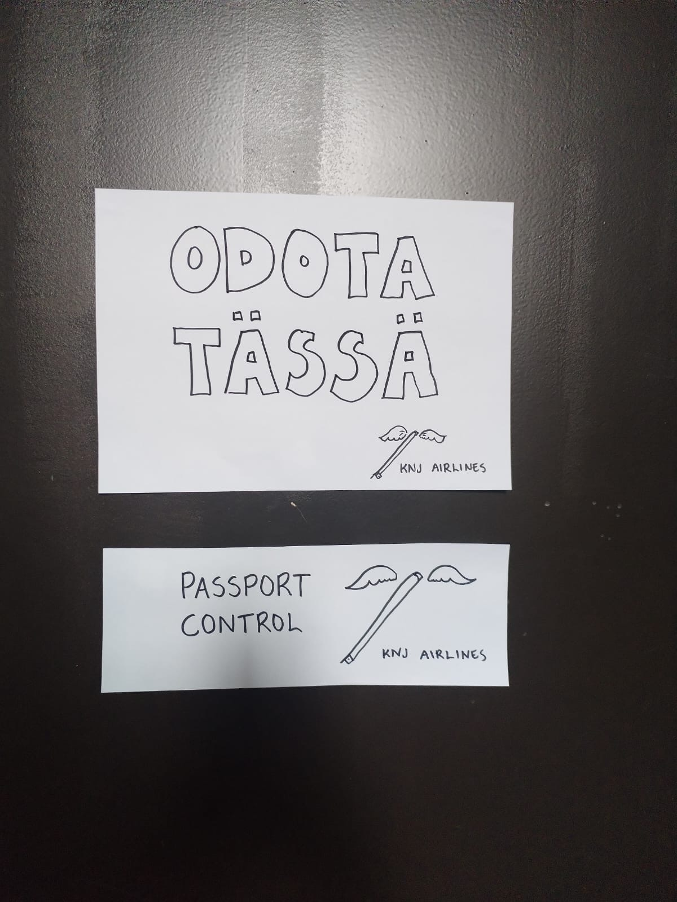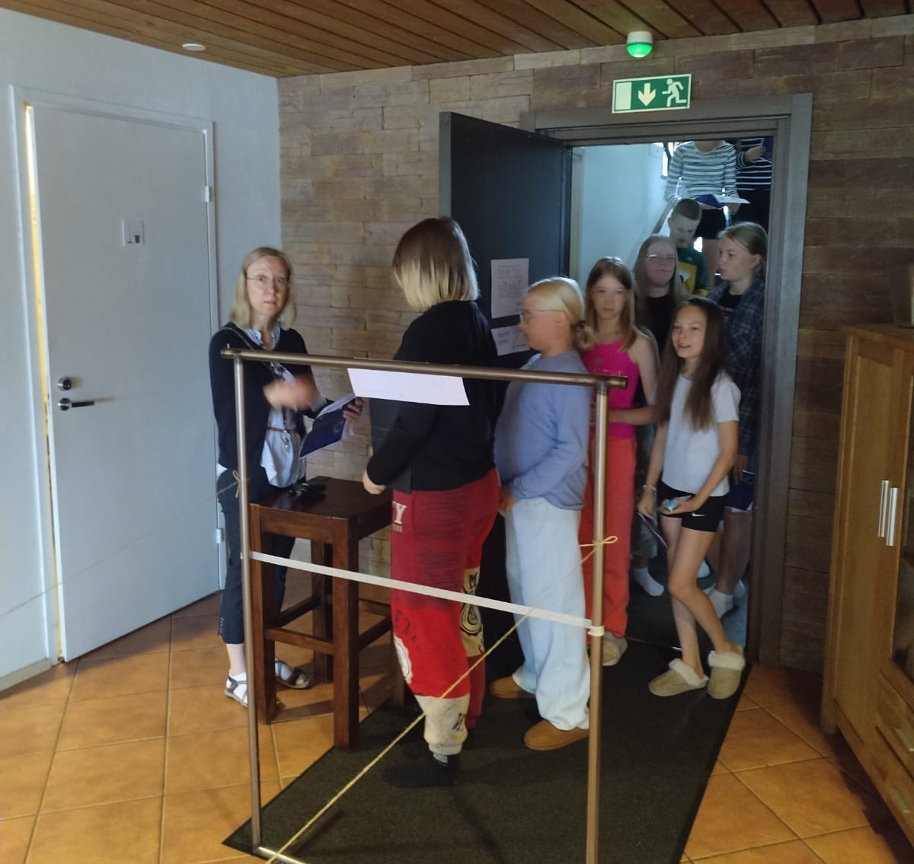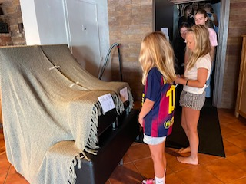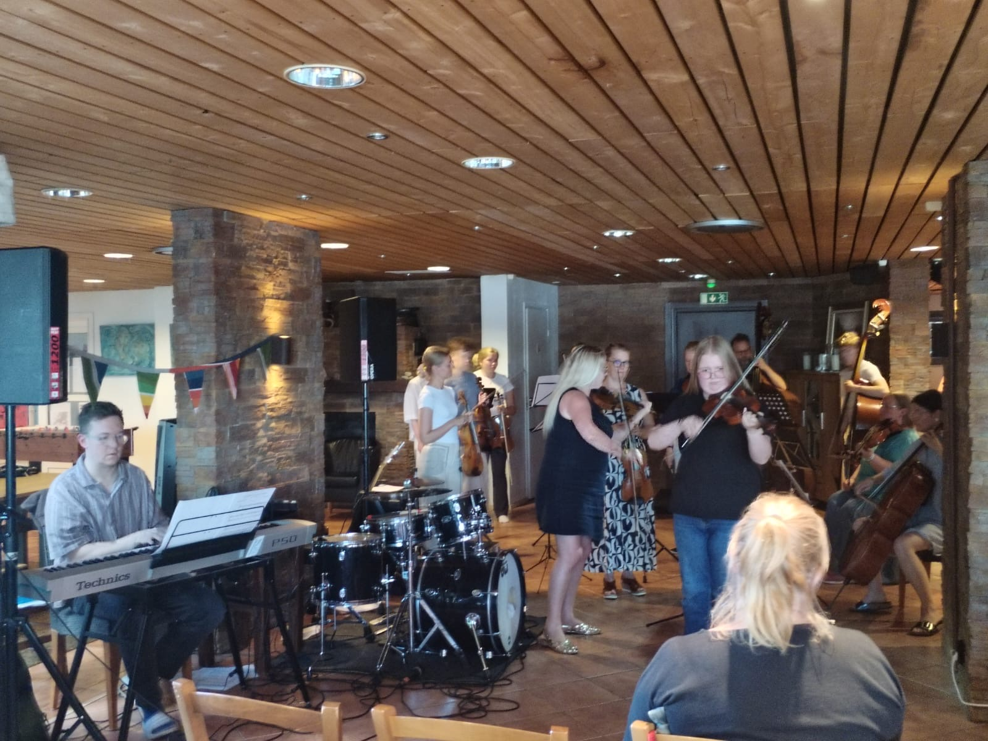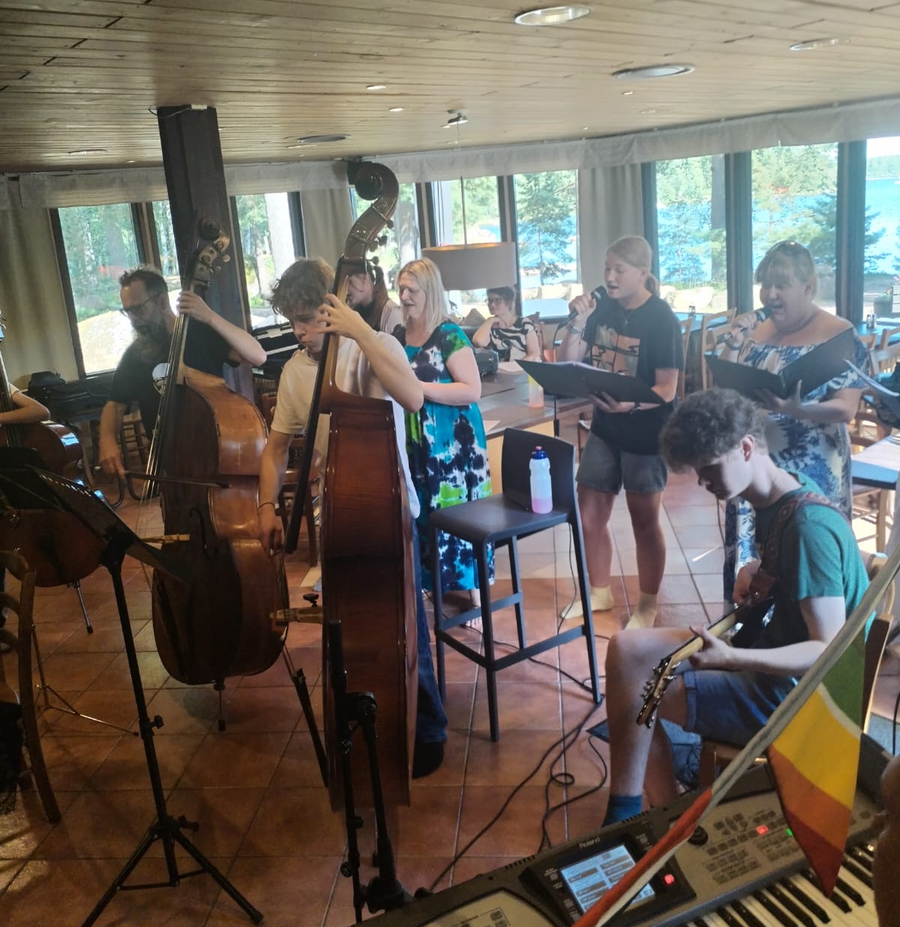

And then finally the long-awaited theme day arrived! The day was spent in the spirit of Eurovision. Both students and teachers had stunning outfits, which really electrified the atmosphere. The day followed the same schedule as the last few days, but there was a chance to go paddling after lunch. The theme day’s evening was spent by enjoying the camp's own Eurovision Song Contest called Campvision (Leiriviisut) where bands performed wonderful songs. The dynamic duo Vilma and Hilma hosted Campvision. During the performances campers played Campvision bingo, and the camp also got videogreetings from Käärijä.

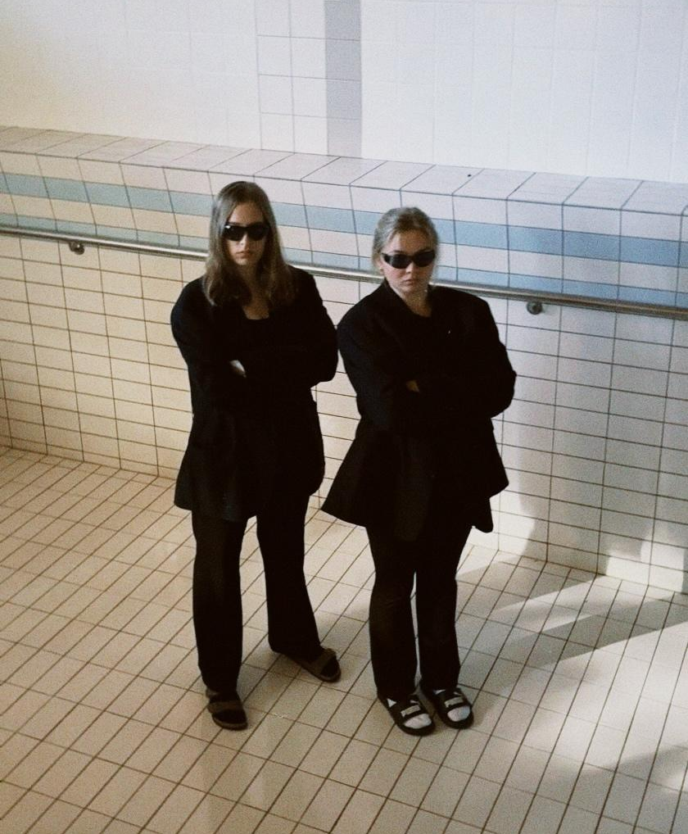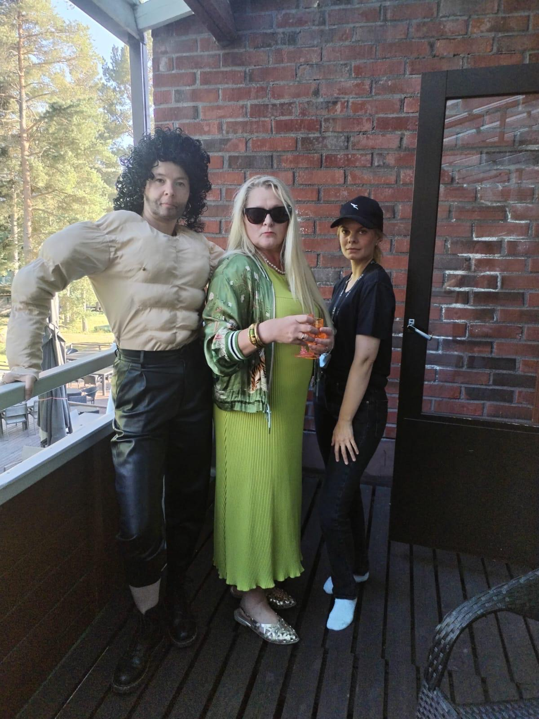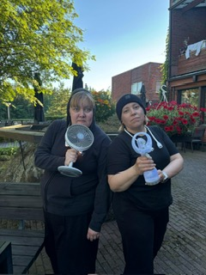
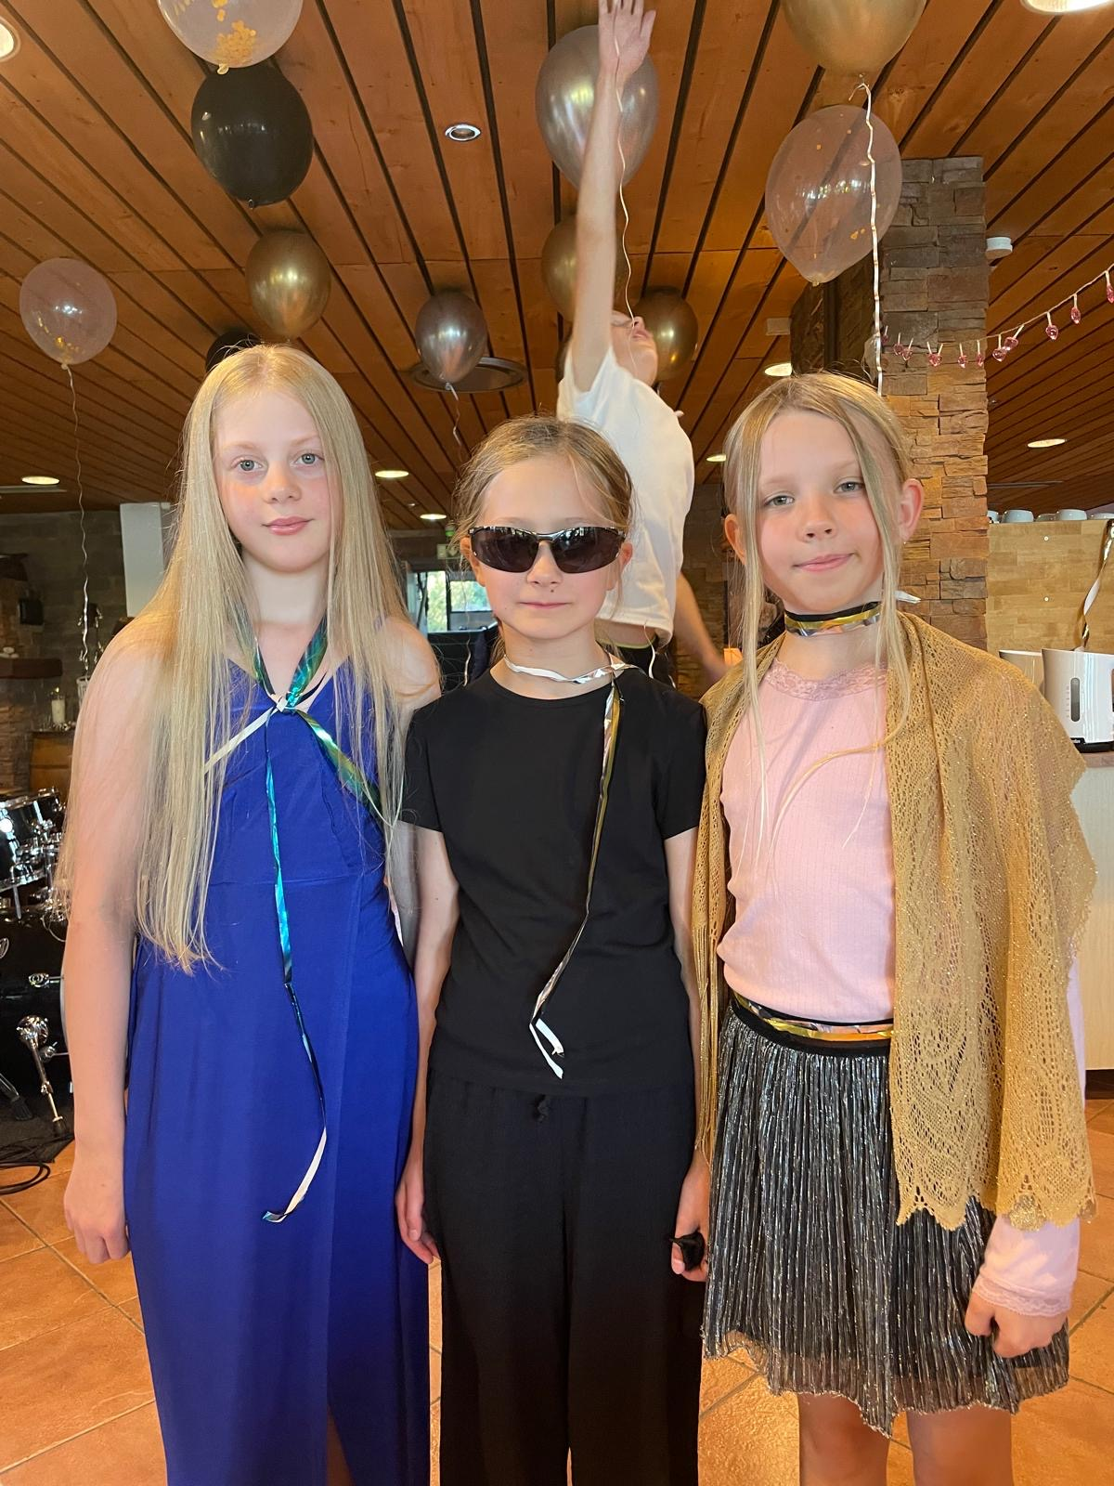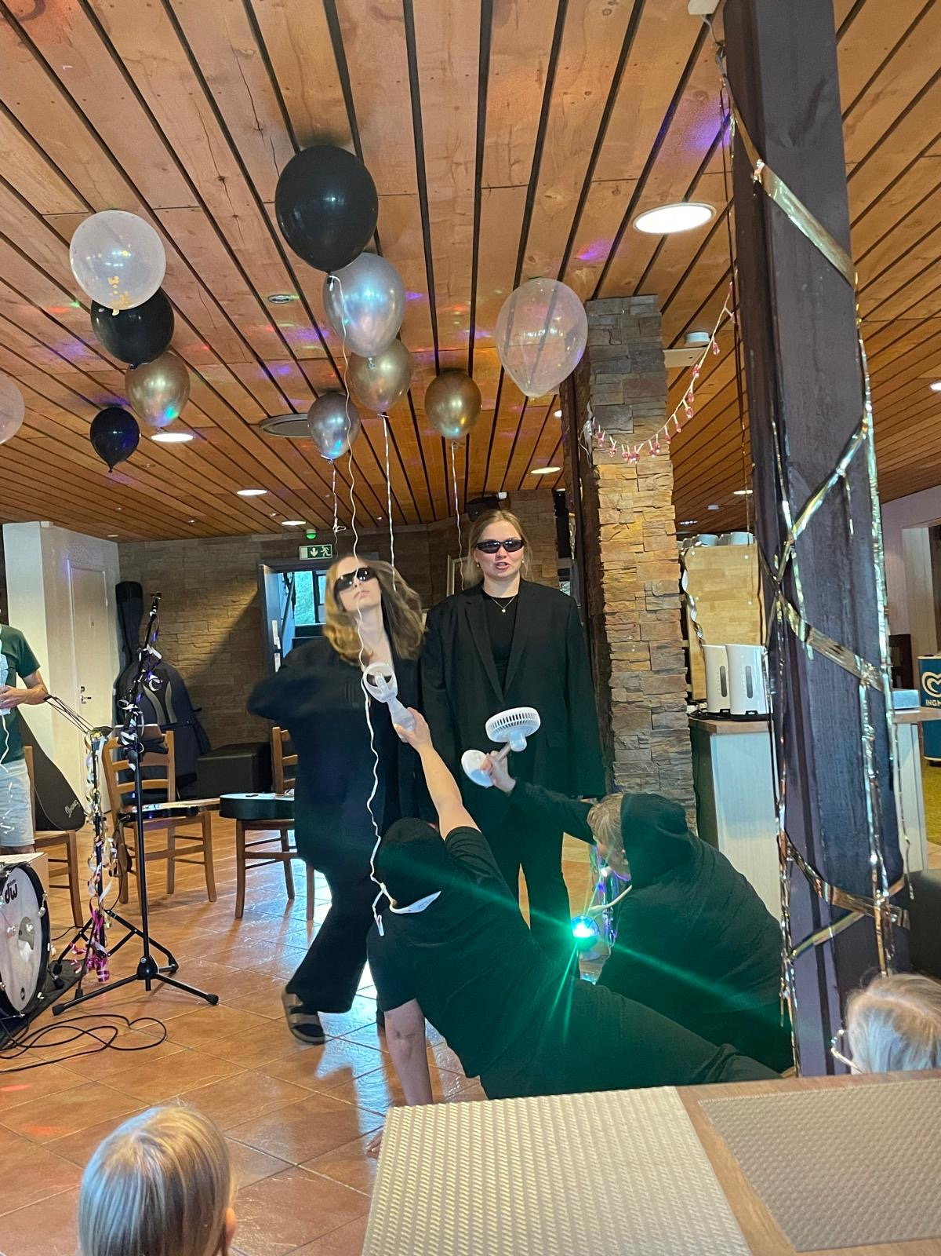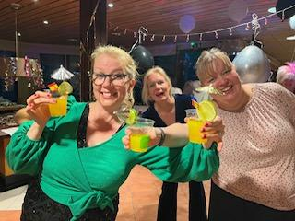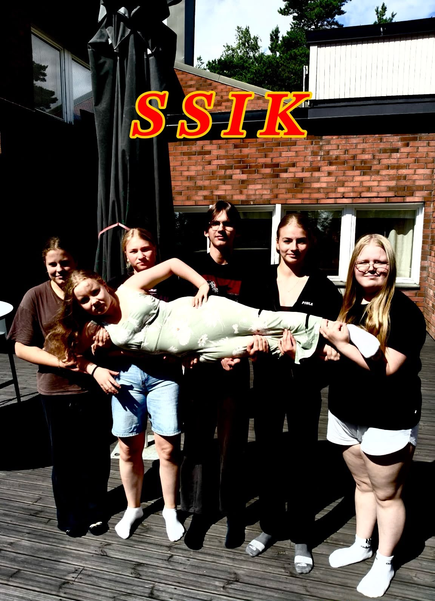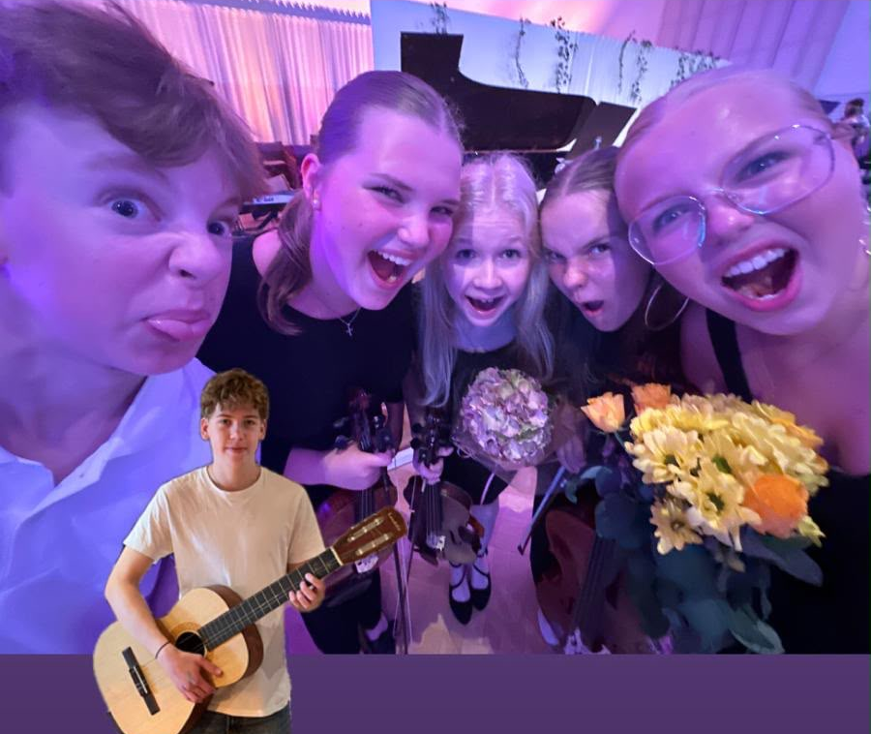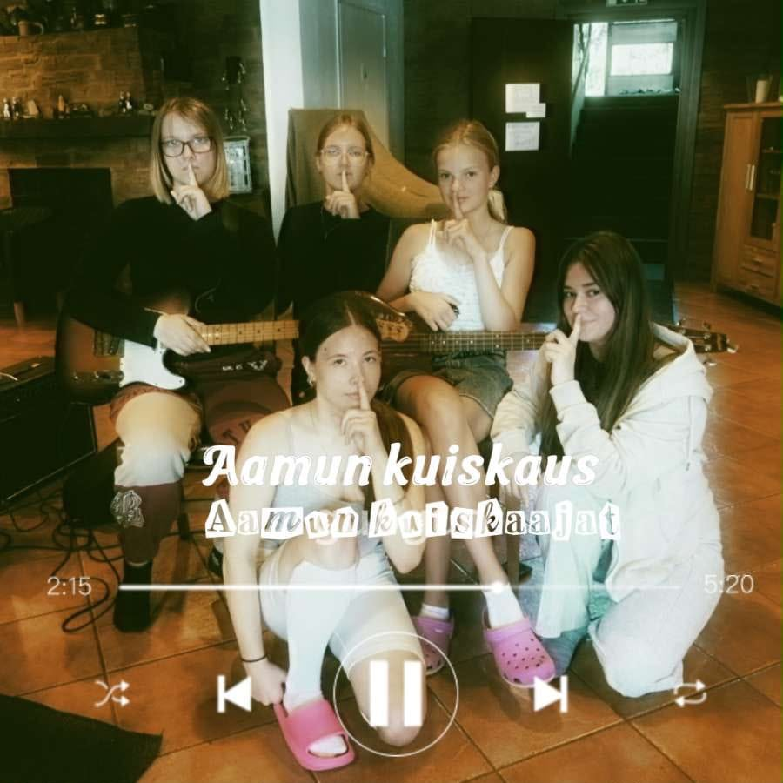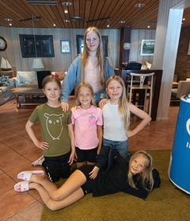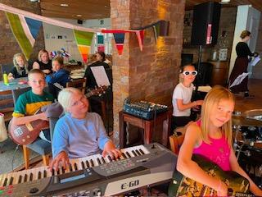

A real highlight this year was the way everyone wholeheartedly embraced the theme! In addition to the security and passport check ups, hilarious “Leirisanomat” and “Leirilööpit” were a real star and bringed a sense of togetherness to the camp. “Leirisanomat” and “Leirilööpit” were magazine posters and special reports inspired by the previous day’s fun events. A big thank you to the editorial team!
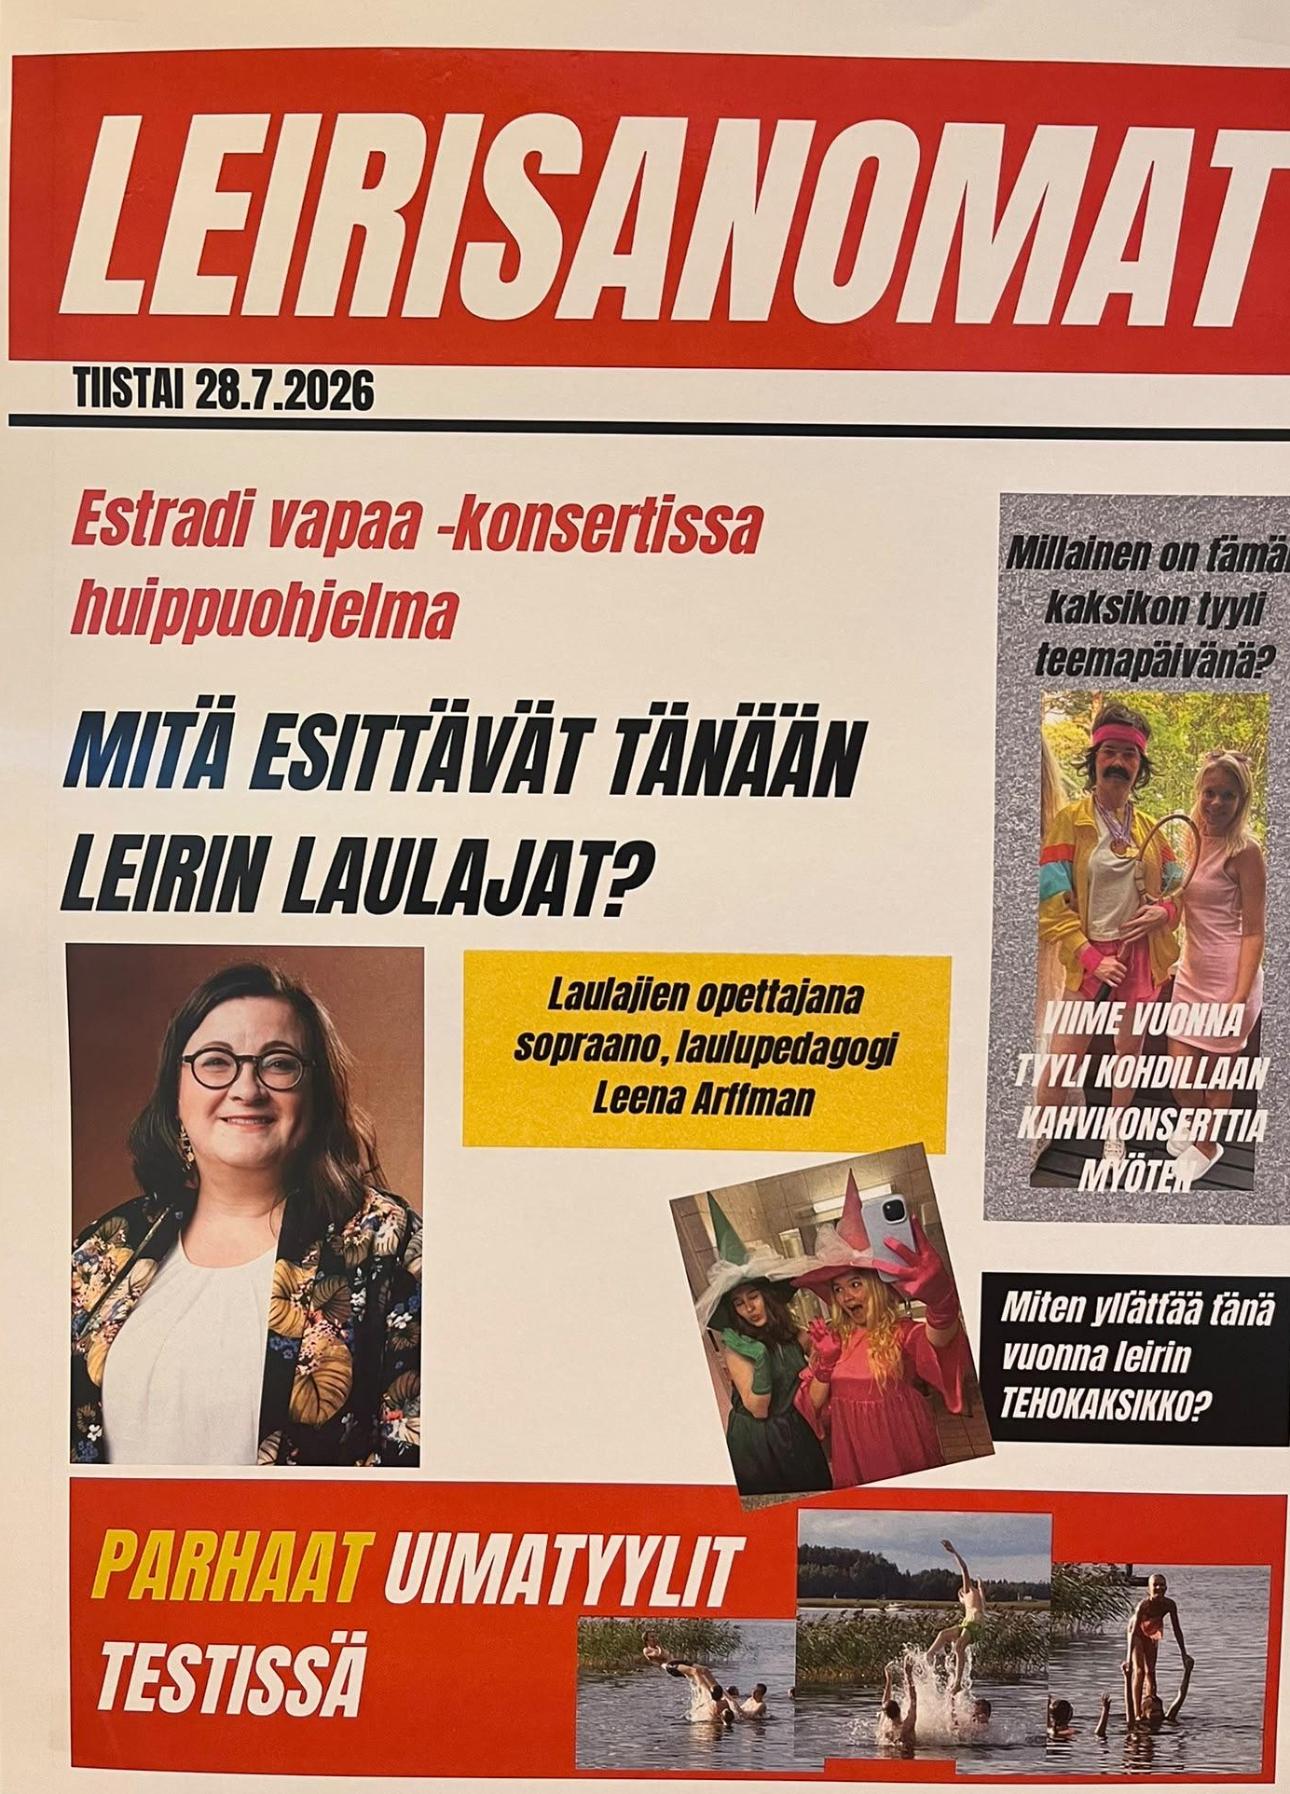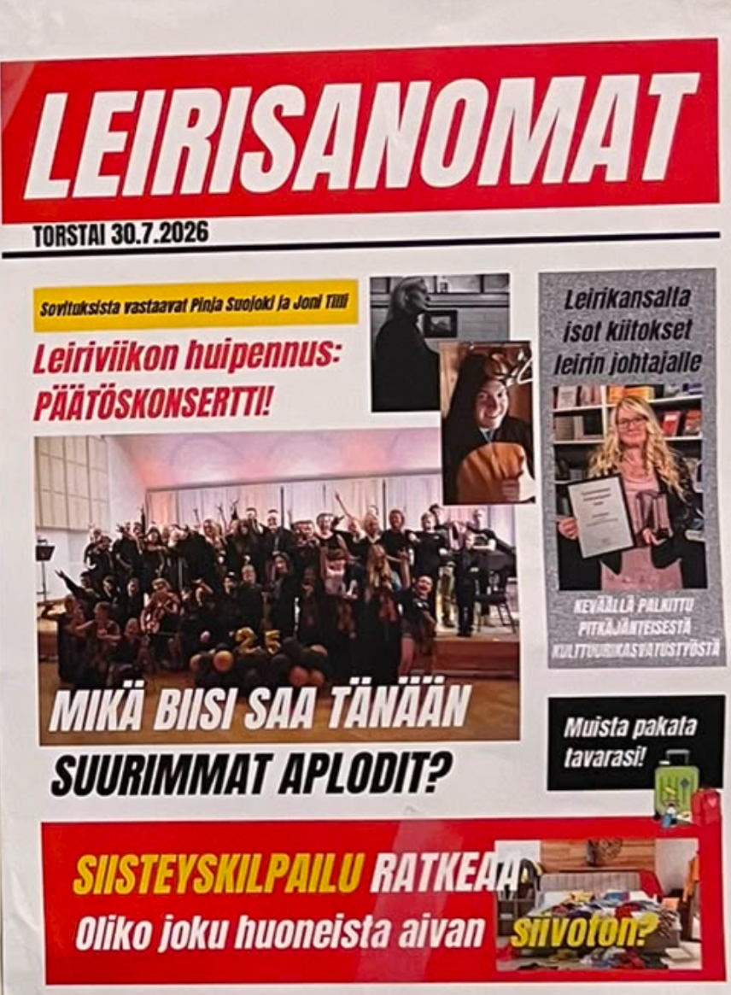
The amazing Music Camp culminated in the concert day that was successfully managed through teamwork. The concert was held in Kotka Concert Hall. Host scripts, visual effects and the lovely music took the audience straight to Europe. The atmosphere was everything you could hope for. The charismatic Leena Arffman and Riikka Viren hosted the concert. The talented Pinja Suojoki and Joni Tilli were responsible for the brilliant arrangements. Samuel Kaijansinkko played electric bass and Hans Lindqvist took care of the visual effects. The concert was once again recorded by Ossi Näveri. So, we will get to enjoy the concert again later in the future.

This year the camp teachers were Eija Vilkki (violin, conducting and artistic leadership), Terhi Vettenranta (violin), Katariina Almgren (violin), Vilma Pöyhönen (violin), Pinja Suojoki (improvisation and conducting), Tanja Wägar (violin), Hanna Silvennoinen (cello), Johannes Raikas (double bass), Leena Arffman (singing), Teemu Seppälä (bands) and Joni Tilli (piano and accompaniment).

Camp supervisors were Tanja Wägar (chief supervisor and practical leadership), Pauliina Hentunen, Riikka Viren, Hilma Nieminen (violin), Timo Kaprio sekä Sirpa Salorinne (viola).

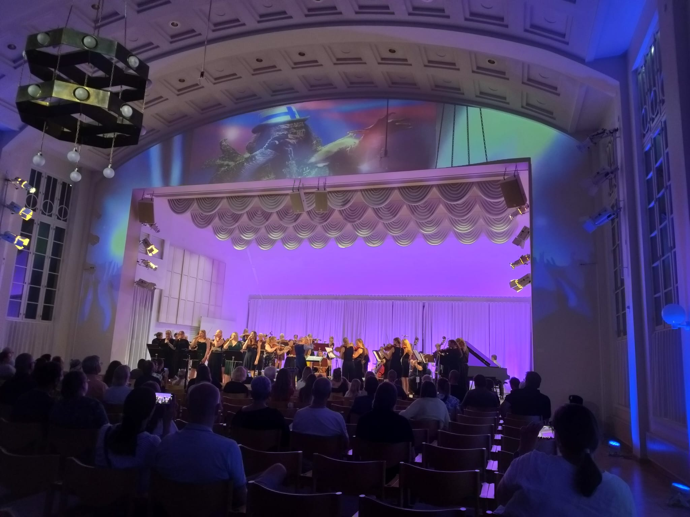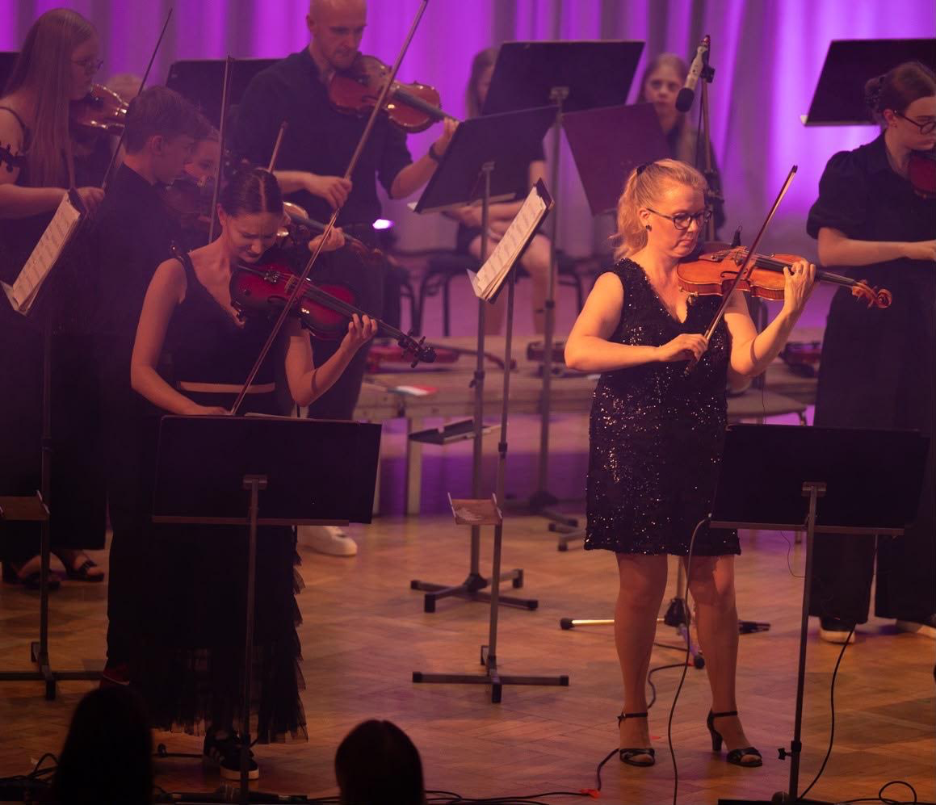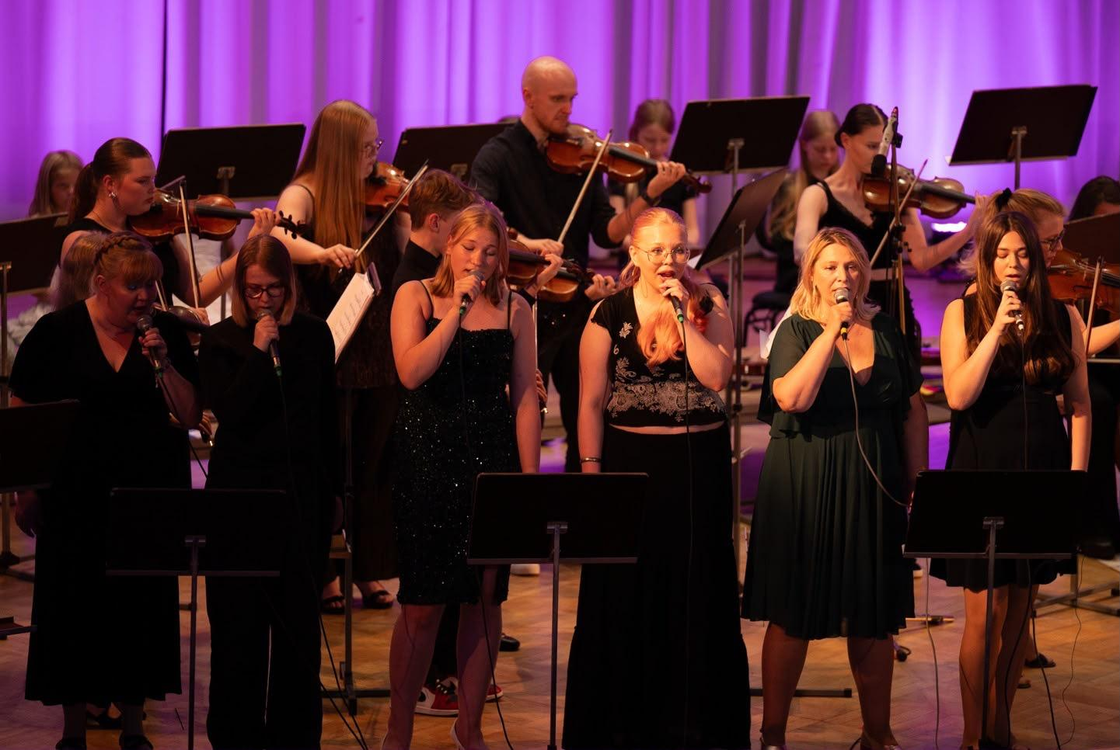

Kotkan Nuoret Jouset Music Camp was sponsored by City of Kotka (Kotkan Kaupunki) and the Kymenlaakso Regional Fund of the Finnish Cultural Foundation (Kymenlaakson Kulttuurirahasto). Warm thank you to the camp’s supporters and to those who made it possible!

